
For Immediate Release:
VJC Concours d’Elegance and JCNA Sanctioned Event

Location:
St. Josephs Villa, 8000 Brook Rd, Richmond, VA 23227
(Parham Road West Exit)

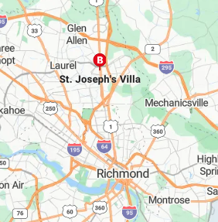

Register On-Line: VaJaguarClub.com/2026VJCConcours

